**DAILY ONLINE ACTIVITIES SUMMARY**

|  |  |  |  |  |  |  |  |  |
| --- | --- | --- | --- | --- | --- | --- | --- | --- |
| **Date:** | **26-06-2020** | | | | | **Name:** | **Deril Quadras** | |
| **Sem & Sec** | **8 A** | | | | | **USN:** | **4AL16CS031** | |
| **Online Test Summary** | | | | | | | | |
| **Subject** | | **-** | | | | | | |
| **Max. Marks** | | **-** | | **Score** | | | **-** | |
| **Certification Course Summary** | | | | | | | | |
| **Course** | **AWS Elastic Load Balancer.** | | | | | | | |
| **Certificate Provider** | | | **AWS** | | **Duration** | | | **30 mins** |
| **Coding Challenges** | | | | | | | | |
| **Problem Statement:**   1. **Write a C Program to Palindrome using function** | | | | | | | | |
| **Status: Solved** | | | | | | | | |
| **Uploaded the report in Github** | | | | | **Yes** | | | |
| **If yes Repository name** | | | | | **Derilquadras/online_c_coding_repository** | | | |
| **Uploaded the report in slack** | | | | | **Yes** | | | |

Online Test Details:

Not Conducted

Certification Course Details:

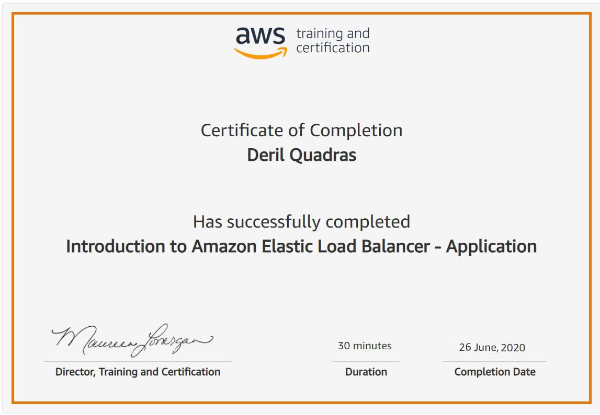

Coding Challenges Details:

**PROGRAM 1 .**

**//Palindrome using function**

**#include<stdio.h>**

**int checkPalindrome();**

**int main()**

**{**

**int num;**

**printf("Enter the number: ");**

**scanf("%d", &num);**

**printf("%d\n",num);**

**checkPalindrome();**

**if(checkPalindrome(num) == 0)**

**printf("%d is a palindrome number.\n",num);**

**else**

**printf("%d is not a palindrome number.\n",num);**

**return 0;**

**}**

**int checkPalindrome(int num)**

**{**

**int temp, rem, sum=0;**

**temp = num;**

**while( num!=0 )**

**{**

**rem = num % 10;**

**sum = sum*10 + rem;**

**num /= 10;**

**}**

**if ( sum == temp )**

**{**

**return 0;**

**}**

**else**

**{**

**return 1;**

**}**

**}**